**COAL LAB 04 - 27 Feb 2025**

**Student Name:** Ibrahim Johar Farooqi

**Student ID:** 23K-0074

***Task 1:***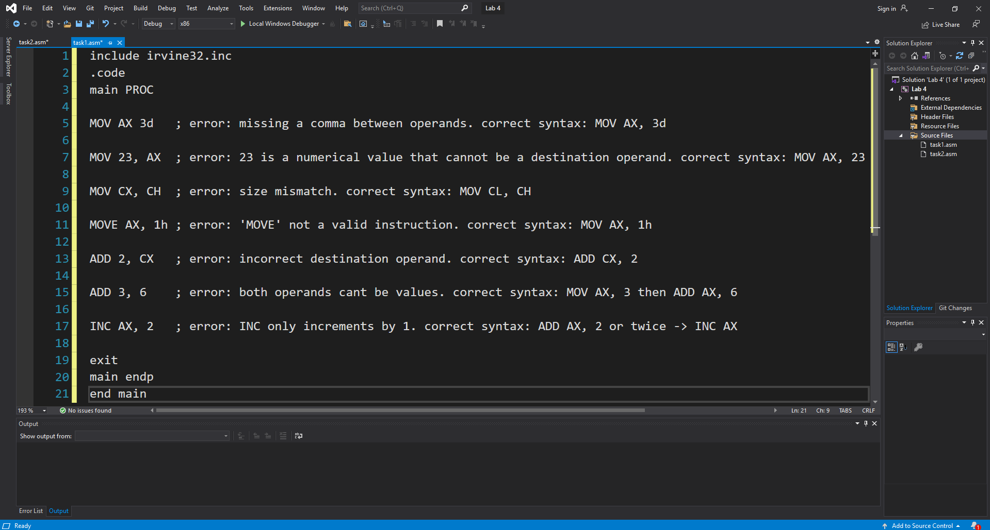

***Task 2:***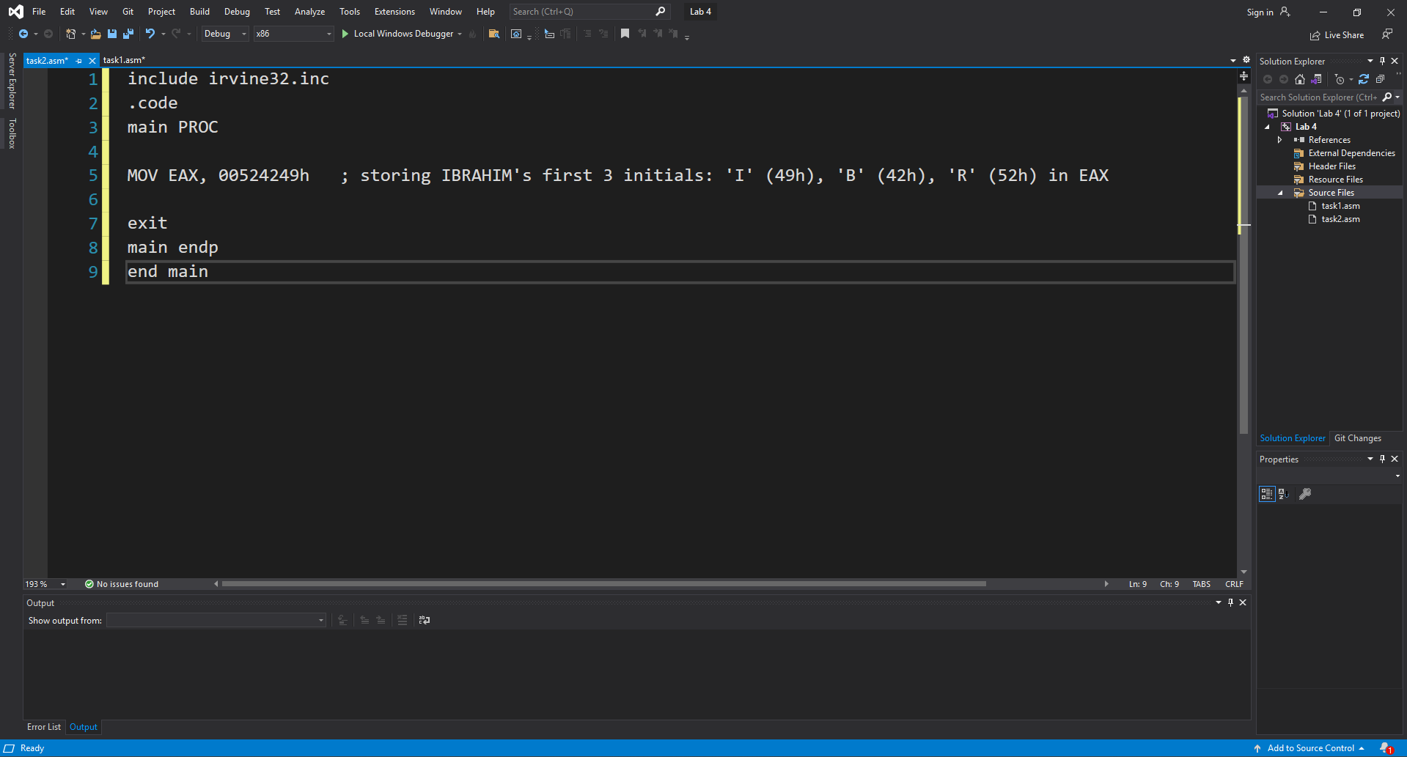

***Task 3:***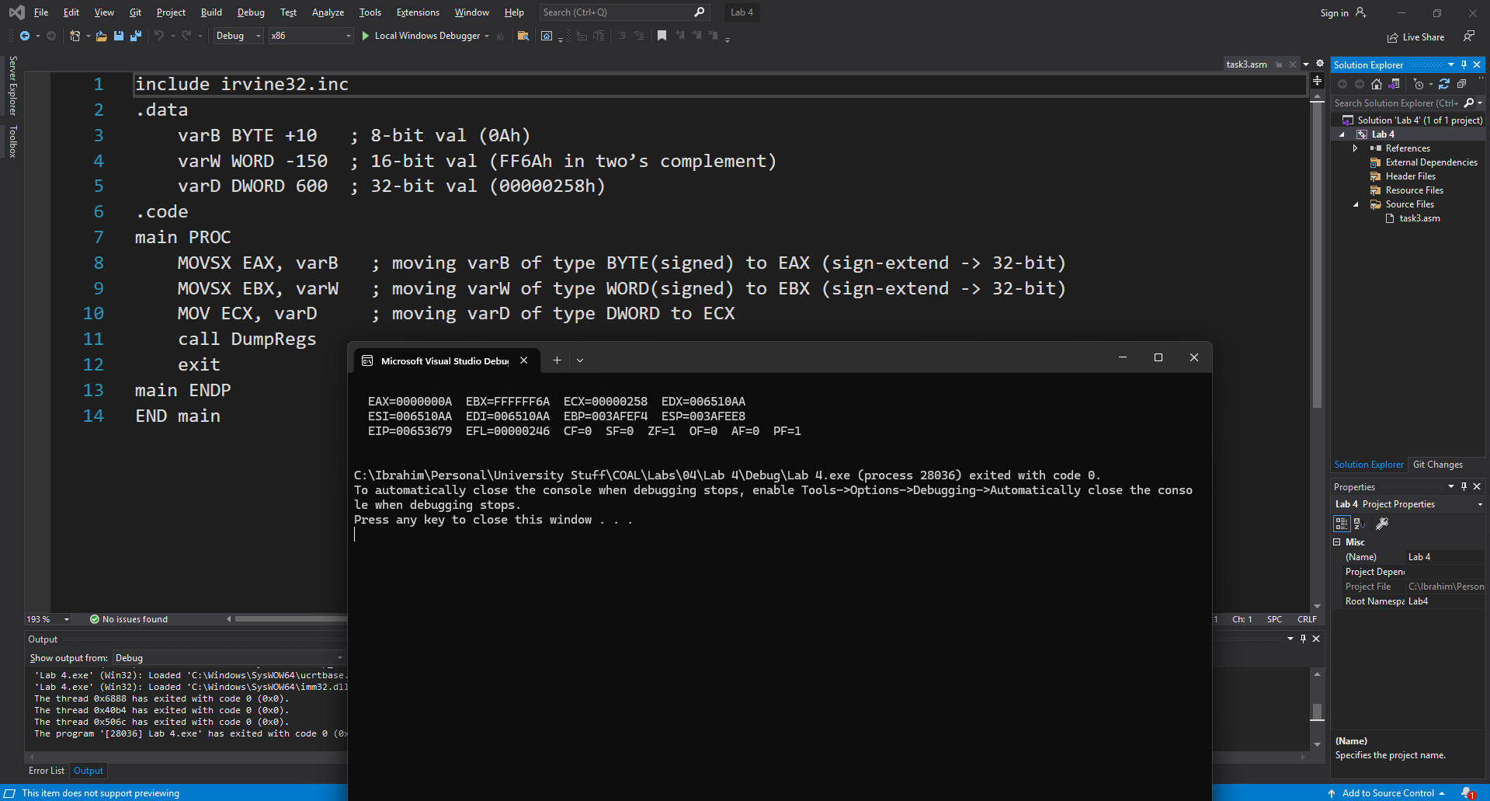

***Task 4:***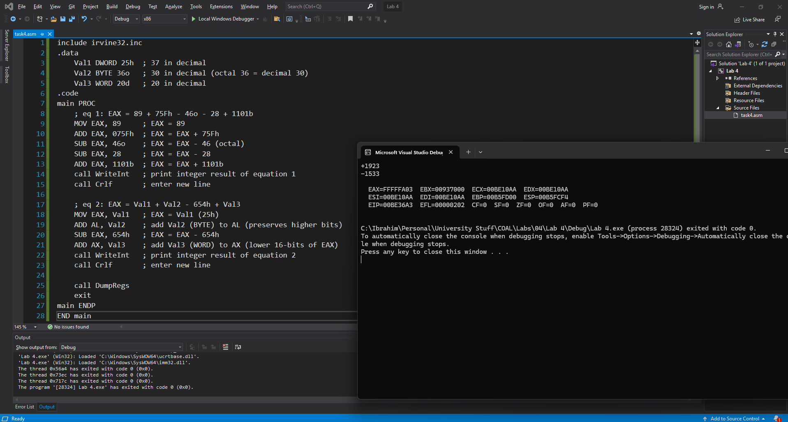

***Task 5:***

(no task 5 found in lab 4 document)

***Task 6:***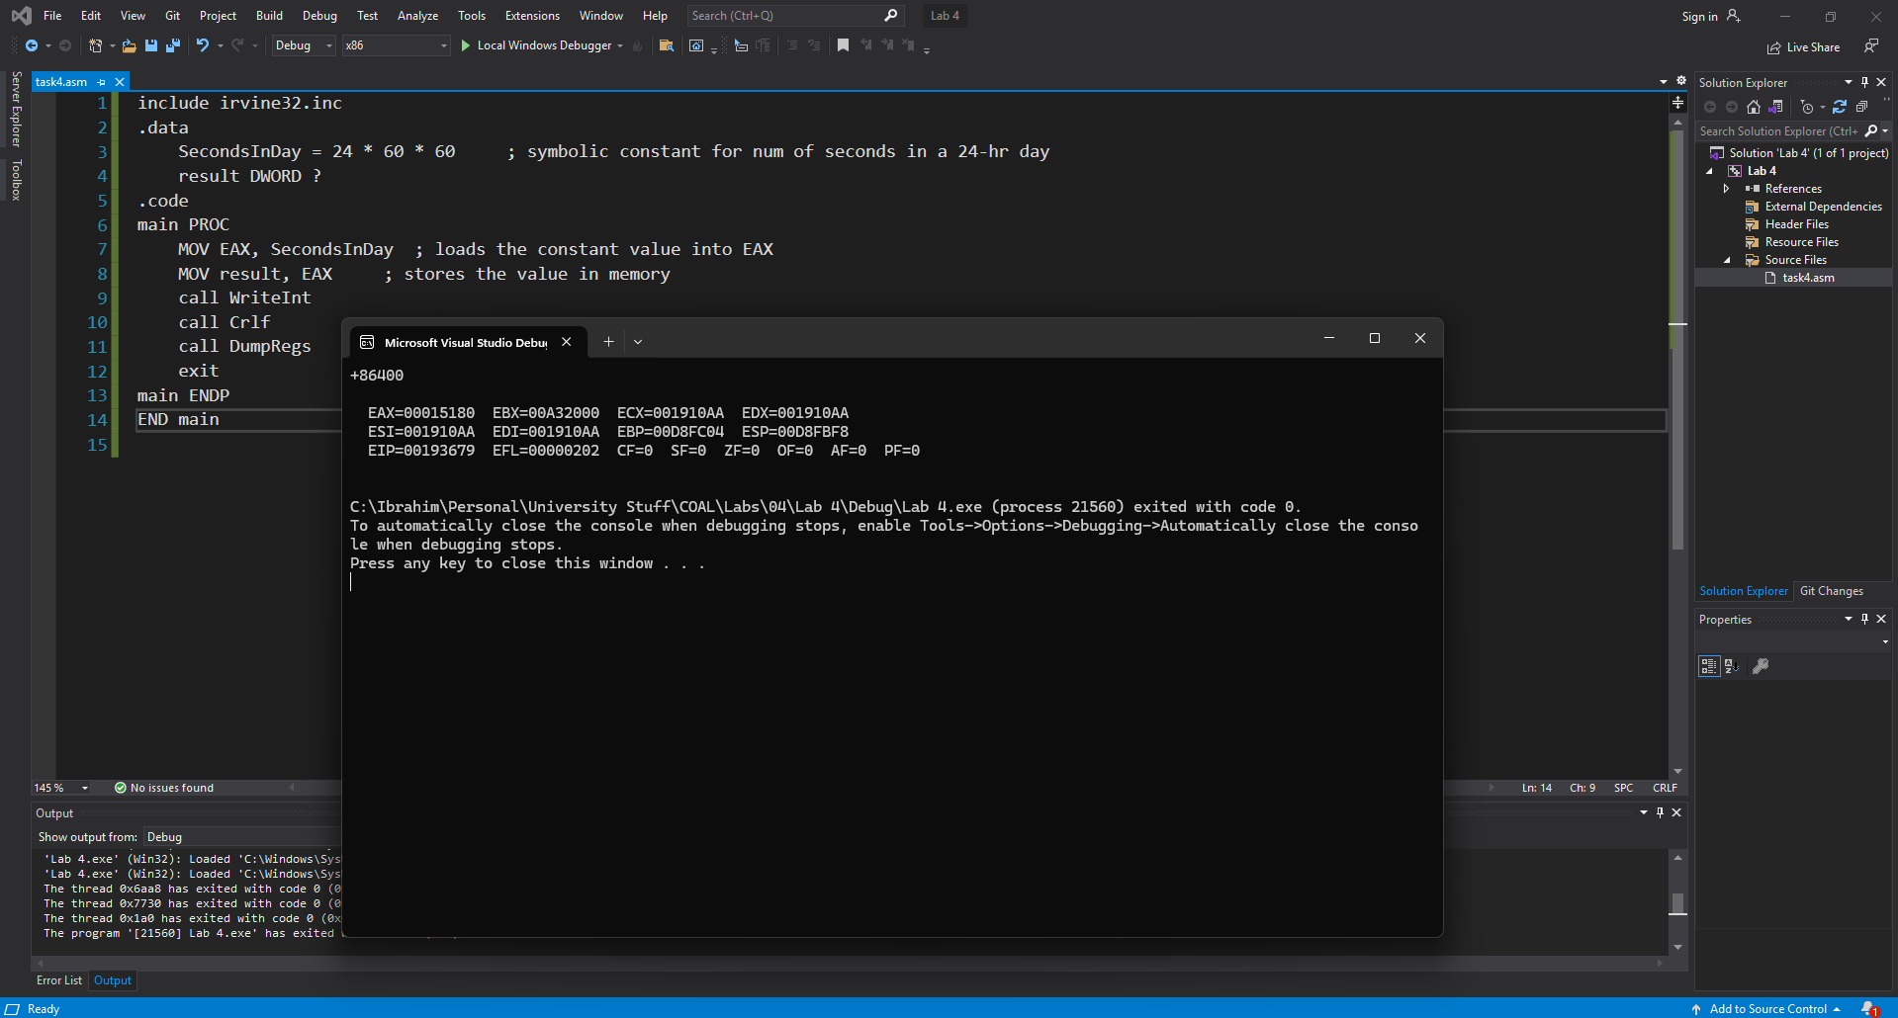

***Task 7:***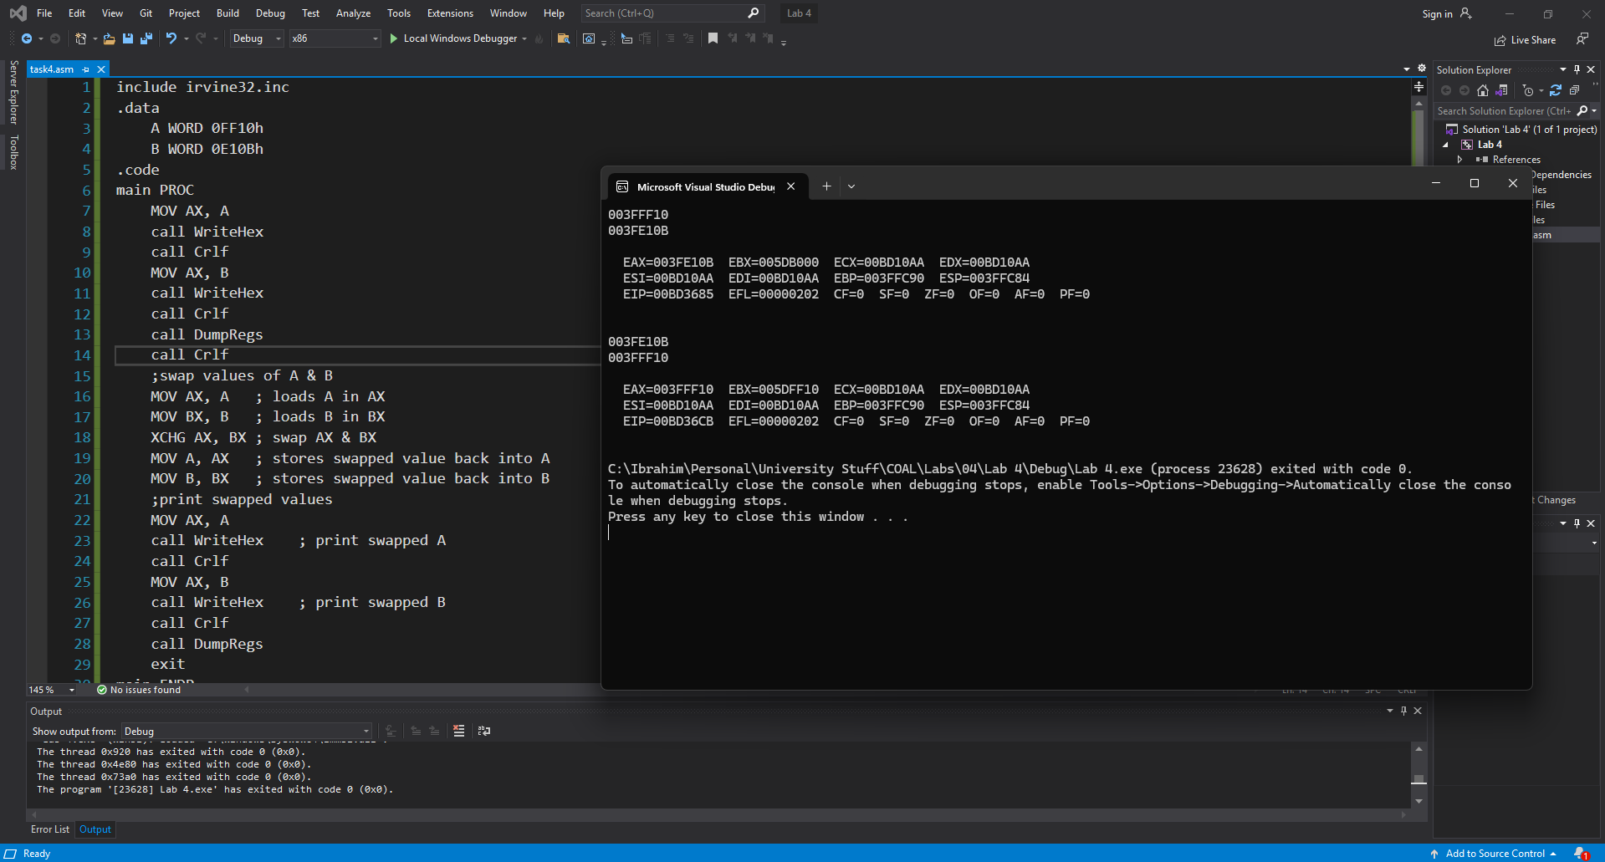

***Task 8:***